**ASR4721 Dashboard Putaway Open TO by date**

**From:** Mary Antonette Santos, Mary Antonette Santos   
**Sent:** Thursday, 04 September, 2014 4:48 PM  
**To:** Chan, Pei-Fong  
**Cc:** Cheang, Sin Loon; Tan, khang-hwee  
**Subject:** RE: Relocation TO data validation

Hi Pei Fong,

Sure, actually im looking on same design as the relocation dashboard that you have created for me.

Raw Data: W02

Reference:

Creation date: blue bar (column a)

Confirmation Date: yellow chart (column b)

(proposed to use different color reference for this report, differ from the relocation report of possible)

No. of TO’s

Below snapshot of the report for your reference. Im trying to attached the file but its too big, please advise if I can save a sample filw in any share drive that you can access.

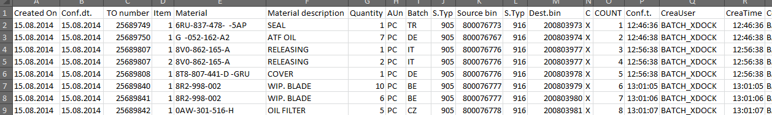

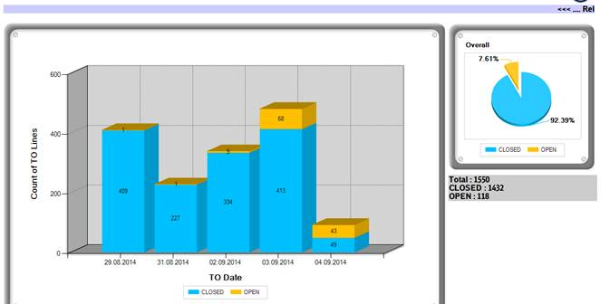

Any further clarification with the data, feel free to let me know.

Thank you,

Mary Santos (Ms)

Warehouse Planner

Contract Logistics/SCM, Operations

Schenker Singapore (Pte) Ltd

2 Changi South Avenue 1

Singapore 486149

DID: +65 6245 5324   Fax: +65 6545 7217

Mobile: +65 9001 8983

**IT CHANGES:**

Generate Dashboard display from Inbound GR (INGR) Stage table which data uploaded from SAP, using EOD INGR

**TABLE: SCH_STAGE_INBOUND_GR_PACKAGE**,

Dashboard display Total TO lines by date with status OPEN/ CLOSED

Status = OPEN when SCH_STAGE_INBOUND_GR_PACKAGE.Confdt = NULL ,

CLOSED when SCH_STAGE_INBOUND_GR_PACKAGE.Confdt <> NULL

Create new dashboard CODE = PUTAWAYTO

Stored Procedure:

EXEC SCH_VW_DASHBOARD_Putaway_OpenTO 373

EXEC SCH_VW_DASHBOARD_Putaway_OpenTO_Detail 373, @c_Category, @c_Status

EXEC SCH_VW_DASHBOARD_Putaway_OpenTO_Detail_Bar 373, @c_Category, @c_BarXValue

<http://sin-vweb2/WMSDB/activity1.aspx?ProgID=9&DashboardCode=PUTAWAYTO>

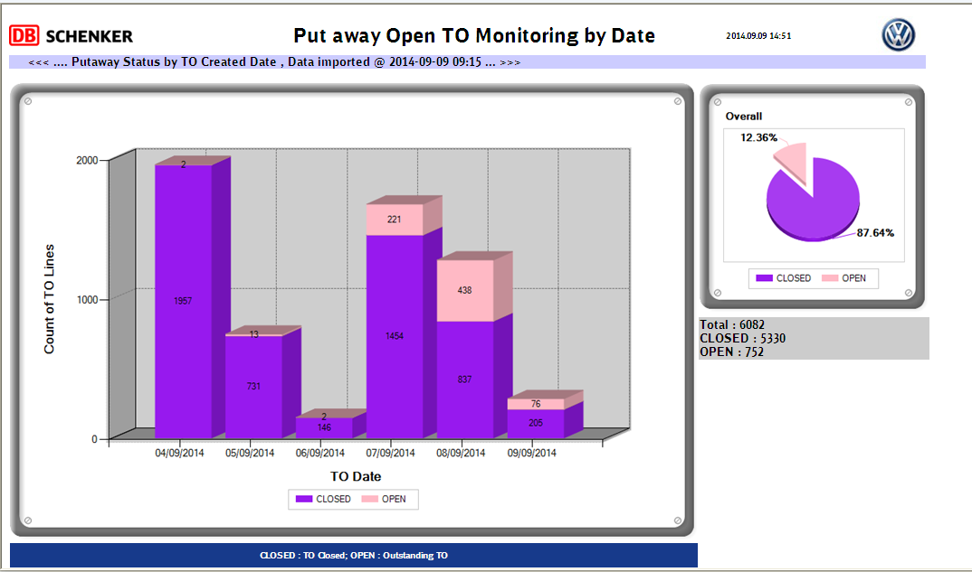

Zoom Detail bar:

